fibonacci数列(二)
时间限制：1000 ms | 内存限制：65535 KB
难度：3
描述
In the Fibonacci integer sequence, F₀ = 0, F₁ = 1, and F_{n} = F_{n − 1} + F_{n − 2} for n ≥ 2. For example, the first ten terms of the Fibonacci sequence are:
0, 1, 1, 2, 3, 5, 8, 13, 21, 34, …
An alternative formula for the Fibonacci sequence is
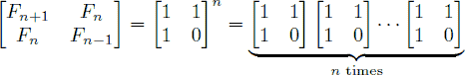.
Given an integer n, your goal is to compute the last 4 digits of F_{n}.
Hint
As a reminder, matrix multiplication is associative, and the product of two 2 × 2 matrices is given by
.
Also, note that raising any 2 × 2 matrix to the 0th power gives the identity matrix:
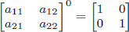.
输入
The input test file will contain multiple test cases. Each test case consists of a single line containing n (where 0 ≤ n ≤ 1,000,000,000). The end-of-file is denoted by a single line containing the number −1.
输出
For each test case, print the last four digits of Fn. If the last four digits of Fn are all zeros, print ‘0’; otherwise, omit any leading zeros (i.e., print Fn mod 10000).
样例输入
0
9
1000000000
-1
样例输出
0
34
6875

